Department Of Civil Engineering N-W.F.P University of Engineering & Technology
Mid Term Examination Fourth Semester (Spring 2007)
CE- 205. Fluid Mechanics 1 For Main Campus, Bannu Campus & GIST

Max. Marks: 80
Attempt all questions.
All questions carry equal marks.
Programmable calculators are not allowed.
Draw neat sketches where necessary.
Assume missing data if any.
Time Allowed: 02: 00 Hrs

1)
a. Define the following terms along with their units:
(i) Weight Density, (ii) Specific Volume, (iii) Pressure head, (iv) Viscosity,
(v) Surface Tension, (vi) Capillarity (6)
b. Develop a general expression for Capillary rise & modify it for water in a clean
glass tube both in mm & inches of water (6)
c. If viscosity of air at certain temperature is O.OOO18 Ns/m², express the same in
poise & centipoises. Provided that density of the air is 1.22 kg/m³, determine its
kinematic viscosity both in Stokes & in SI units. (8)

2)a. An inverted U tube manometer is used to measure the pressure difference b/w two pipes one carrying oil of specific gravity 0.8 & the other water. Considering the configuration in the figure, determine the pressure differential taking the density
of air to be 1.22 kg/m .
(10)
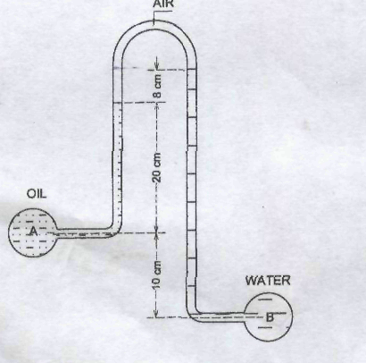
b. A simple manometer is used to measure the pressure of oil (Specific gravity =0.8}
flowing in a pipe line. If the right limb is open to the atmosphere & left limb is
connected to the pipe. The center of the pipe is 3.6 inches below the level of
mercury (Specific gravity = 13.6) in the right limb. If the difference of mercury
level in the two limbs is 6 inches, draw the neat sketch of the manometer &
determine the absolute pressure of the oil in slug/ft² (10)
3)
a. Determine the magnitude & location of the resultant force on an inclined
Submerged plane surface. (10)
b. A triangular area, base 1.25m & altitude 3m is immersed vertically in water such
that its vertex is below the base. If the center of pressure is 200mm below the
center of gravity, how far is the base below the liquid surface? (10)
4)
a. Differentiate between the following
(i) Path lines & stream lines (ii) Laminar & turbulent flow
(iii) Absolute & gauge Pressures (iv) Steady & unsteady flow
(v) Uniform & Non Uniform flows (15)

b. Write a short note on compressibility of liquids (05)

